Performance report

System details:  
  
Operating system: Microsoft Windows 11 Pro, Version 10.0.22631  
DirectX runtime version: DirectX 12  
Driver: Game Ready Driver - 566.14 - Tue Nov 12, 2024  
CPU: 13th Gen Intel(R) Core(TM) i9-13980HX  
RAM: 32.0 GB  
Storage: SSD - 1.9 TB  
  
Graphics card  
GPU processor: NVIDIA GeForce RTX 4090 Laptop GPU  
Graphics clock: 2040 MHz  
Memory bandwidth: 576.064 GB/s  
Dedicated video memory: 16376 MB GDDR6  
  
Display (1): LG Electronics LG ULTRAGEAR  
Resolution: 2560 x 1440  
Refresh rate: 144 Hz

Tested title:  
  
World of Warships  
Build ID: 16989406  
Graphics quality: Maximum preset

**Main results:**

Min Framerate, FPS: 32.8  
Max Framerate, FPS: 142.0  
Min GPU1 usage, %: 3.0  
Max GPU1 usage, %: 100.0  
Min CPU usage, %: 5.58  
Max CPU usage, %: 63.12

# GPU1 temperature, °C

Menu and Gameplay

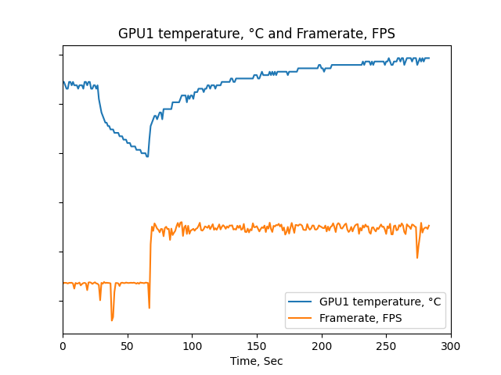

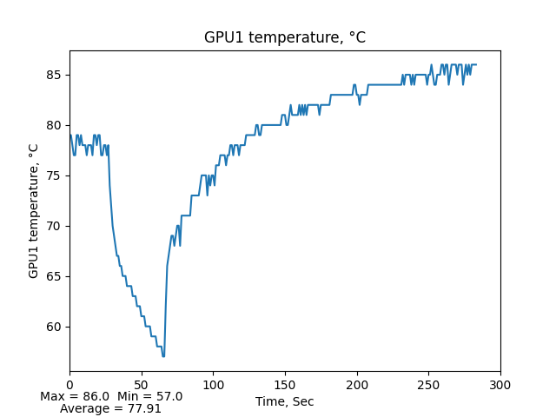

Menu

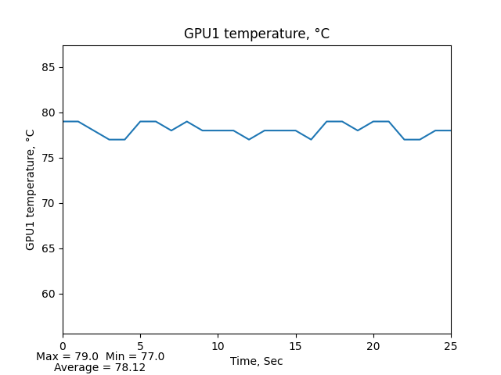

Gameplay

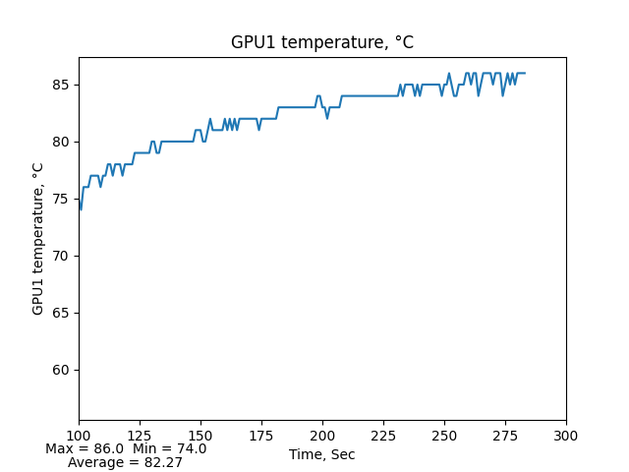

# GPU1 usage, %

Menu and Gameplay

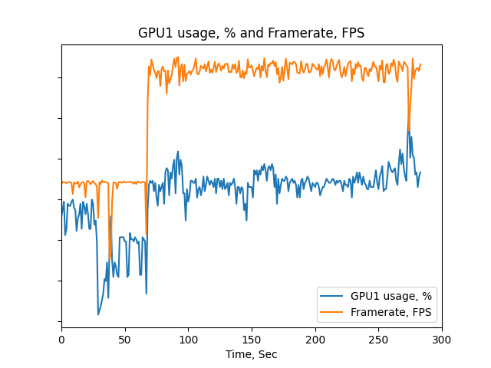

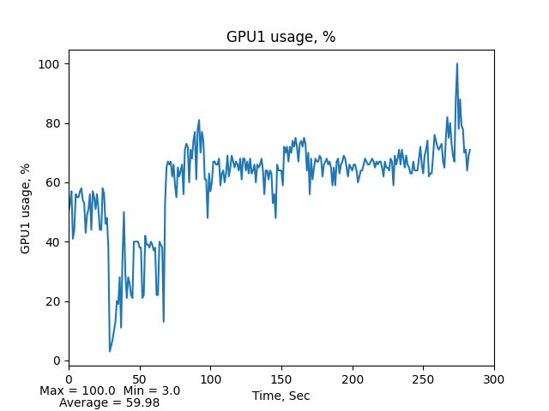

Menu

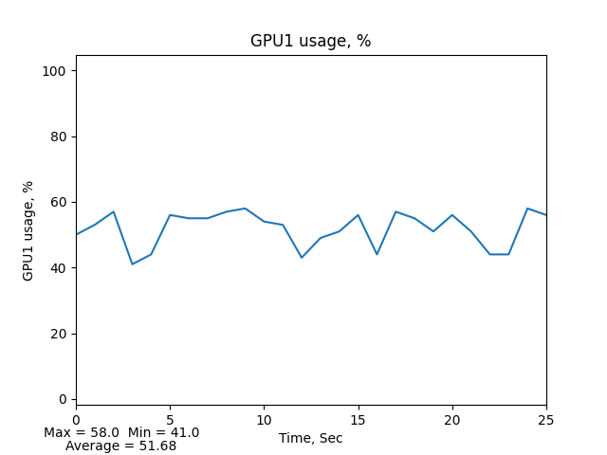

Gameplay

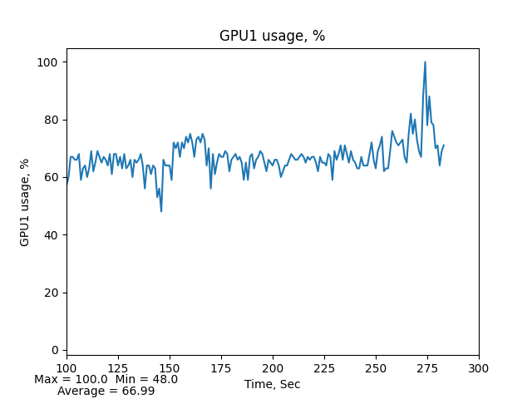

# CPU temperature, °C

Menu and Gameplay

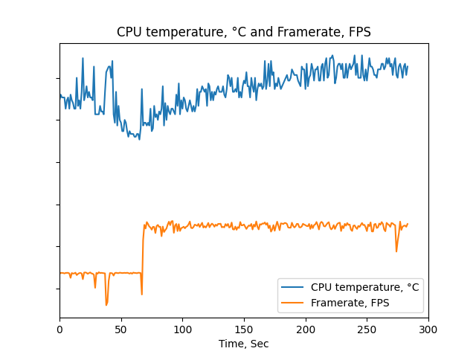

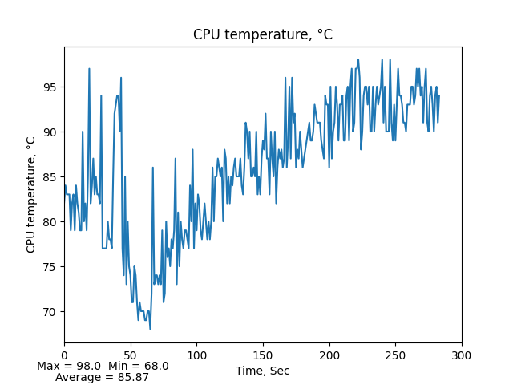

Menu

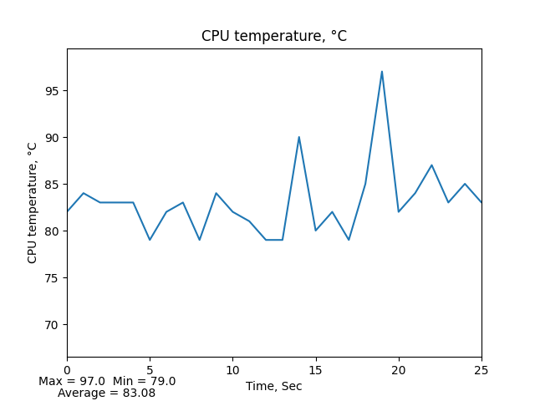

Gameplay

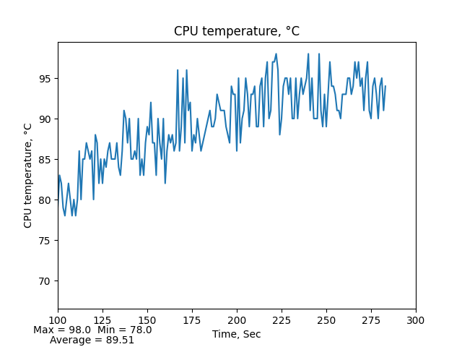

# CPU usage, %

Menu and Gameplay

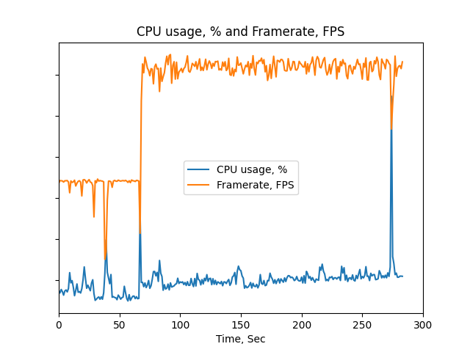

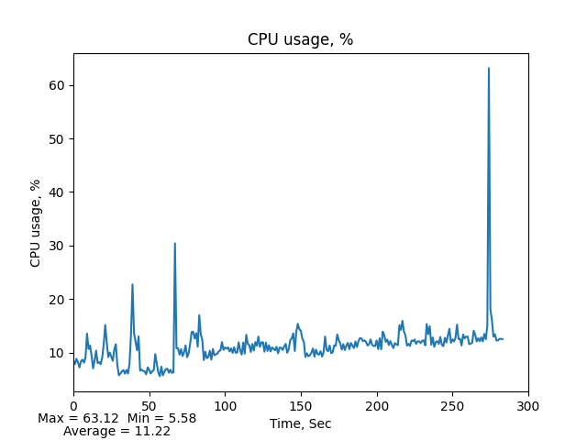

Menu

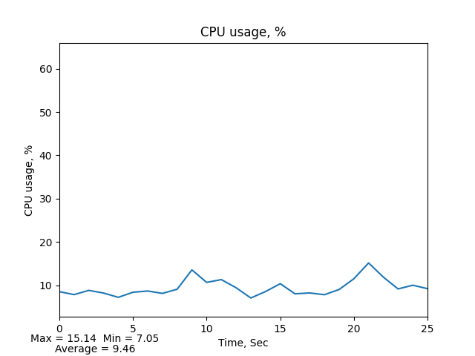

Gameplay

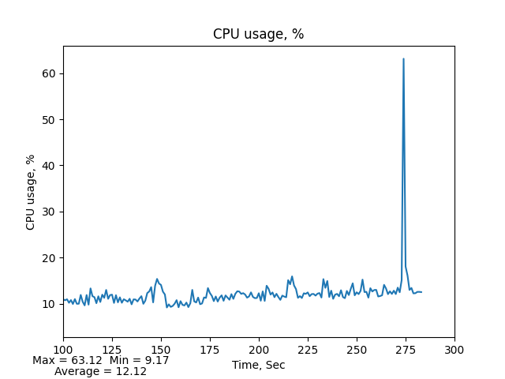

# RAM usage, MB

Menu and Gameplay

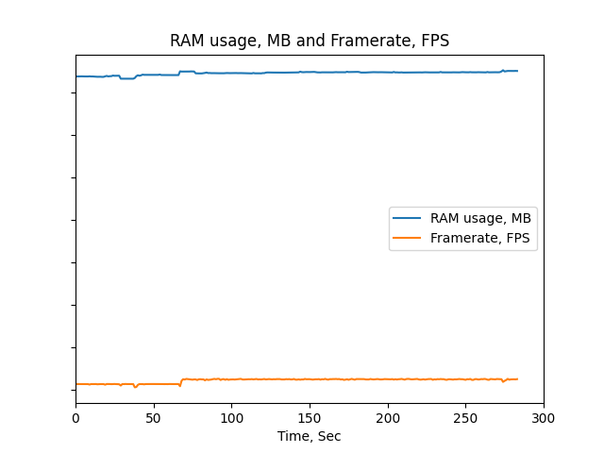

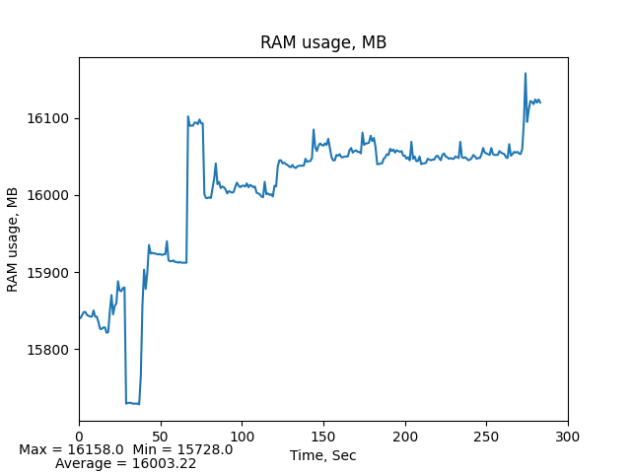

Menu

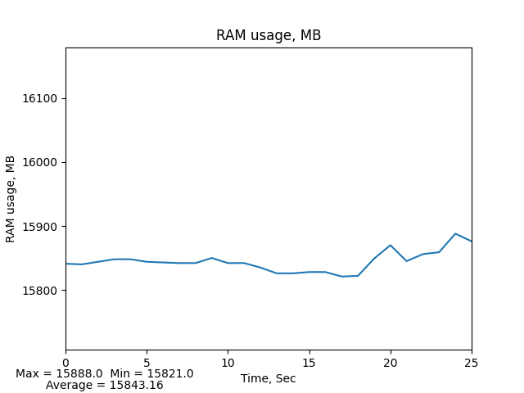

Gameplay

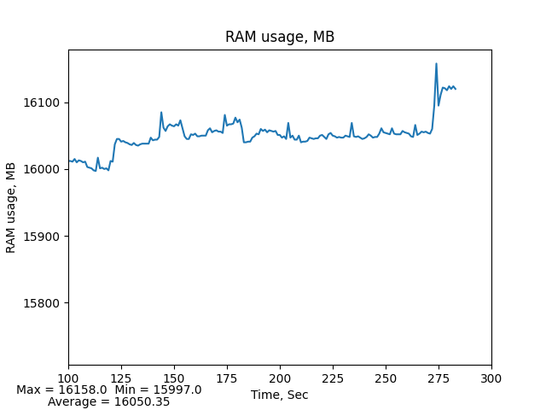

# Framerate, FPS

Menu and Gameplay

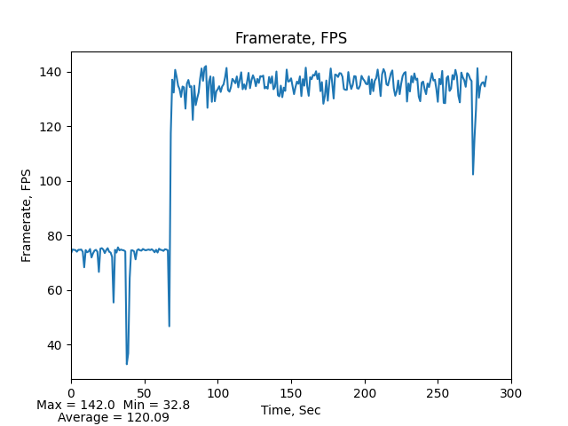

Menu

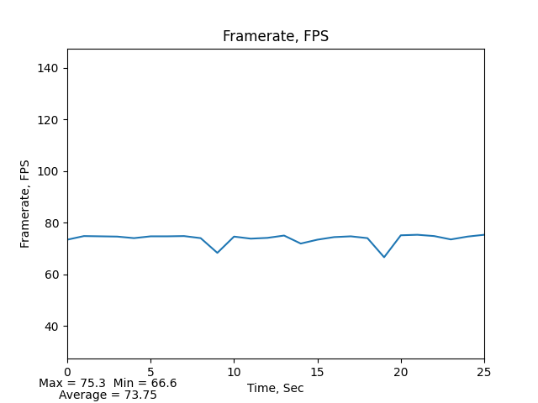

Gameplay

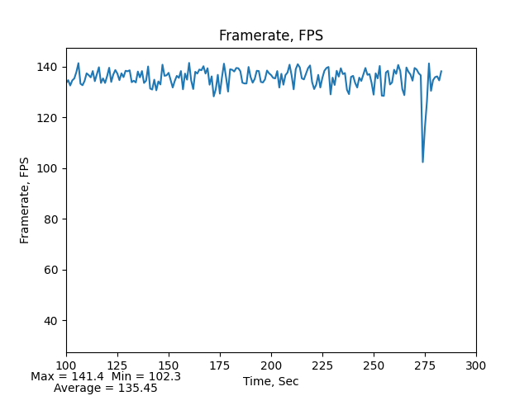

# HDD1 usage, %

Menu and Gameplay

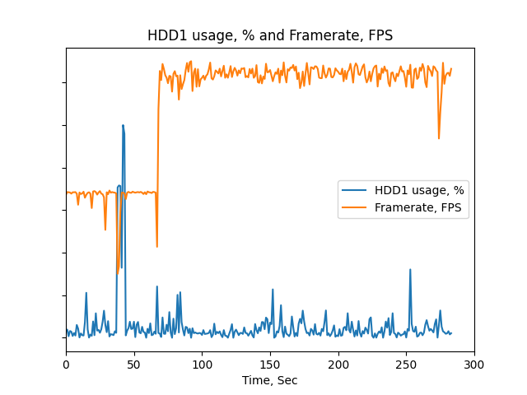

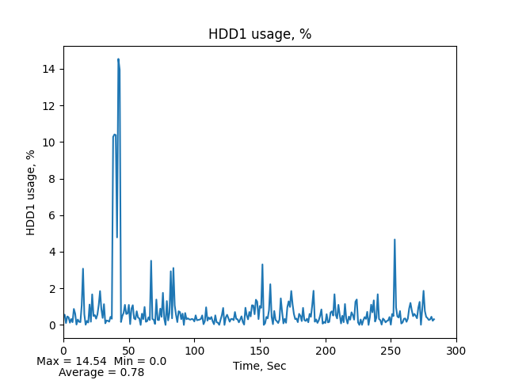

Menu

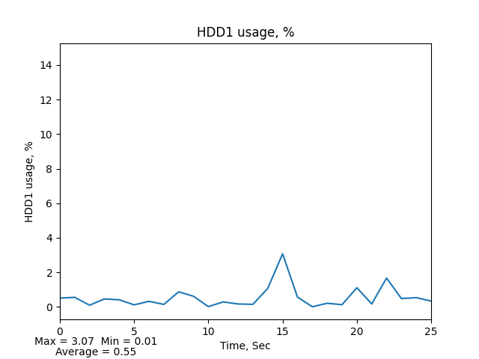

Gameplay

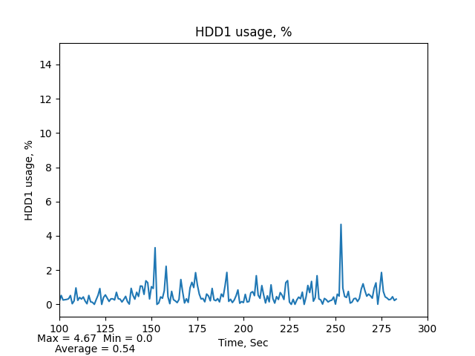

# NET3 download rate, MB/s

Menu and Gameplay

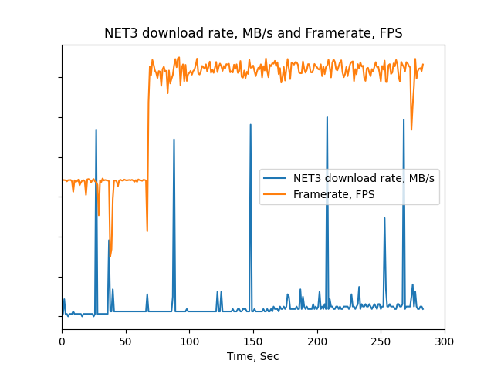

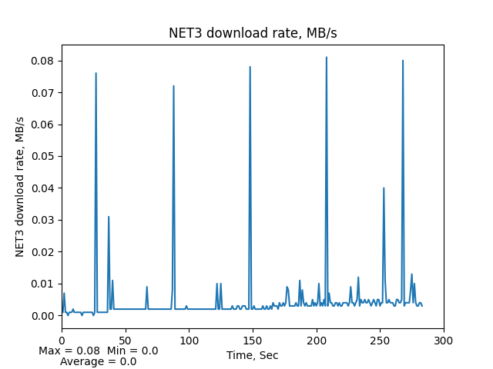

Menu

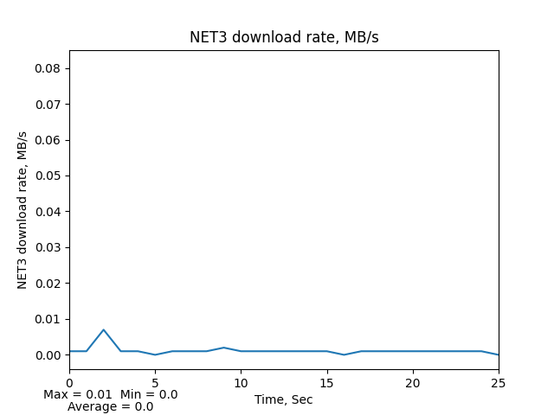

Gameplay

